Lab instructions

Part 1: Front end and backend.
- Create an empty directory: workapace and open it on VS Code.
- Run the command:
npm create vite@latest
- Provide project name: frontend
- From the menu choose: react
- From the menu choose: TypeScript
- Accept installation of npm.
- Press CTRL+C to get back to the terminal.
- Switch to the frontend directory and run the application:
cd frontend
npm run dev
- Click on the localhost link with the port number selected for you: http://localhost:5173/ and verify the app is running on the browser. You can click on the button to start counting.
- Navigate to the src directory then open the file: App.tsx and replace it with the code from file called: code1-frontend.txt from the repository.
- Run the application again and verify that you can see a table of employees:
npm run dev
- We’ll leave the frontend for now and update it later to request the data from the backed rather than hosting the data within the frontend. If you still running the application, stop the app: CTRL+C and navigate back to the workspace directory using the command: cd ..
- Verify the current directory: pwd
- In the VS Code extensions, search for and install the C#.NET dev kit.
- Create a basic backend application:
dotnet new webapi --use-controllers -n backend
- Explore the contents of the backend project and verify that you have:

File | Brief Description
Program.cs | The main entry point of the application. It configures services (like controllers), middleware (such as routing), and starts the web API.
WeatherForecastController.cs | Handles HTTP requests (e.g., GET) and returns weather data. This is where the API endpoints are defined.
WeatherForecast.cs | Defines the data model for the weather forecast, including properties like date, temperature, and summary.
appsettings.json | Stores configuration settings such as logging levels and other application parameters used across the app.

- Run the application:
cd frontend
dotnet restore
dotnet run
Click on the application link. You won’t see any content in the browser because this is a backend API. To test it, you need to send requests from a frontend application or use a tool such as Postman.
- Using the browser request the backend data. This is basically an HTTP request using the GET method.
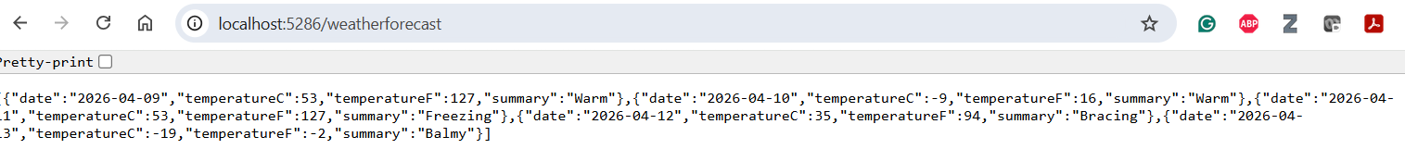
- Repeat the same test using postman: from the + sign, select HTTP.
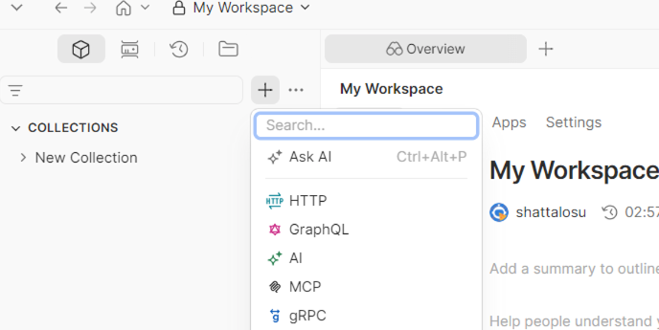
You should see status 200 OK and the data returned in JSON format. 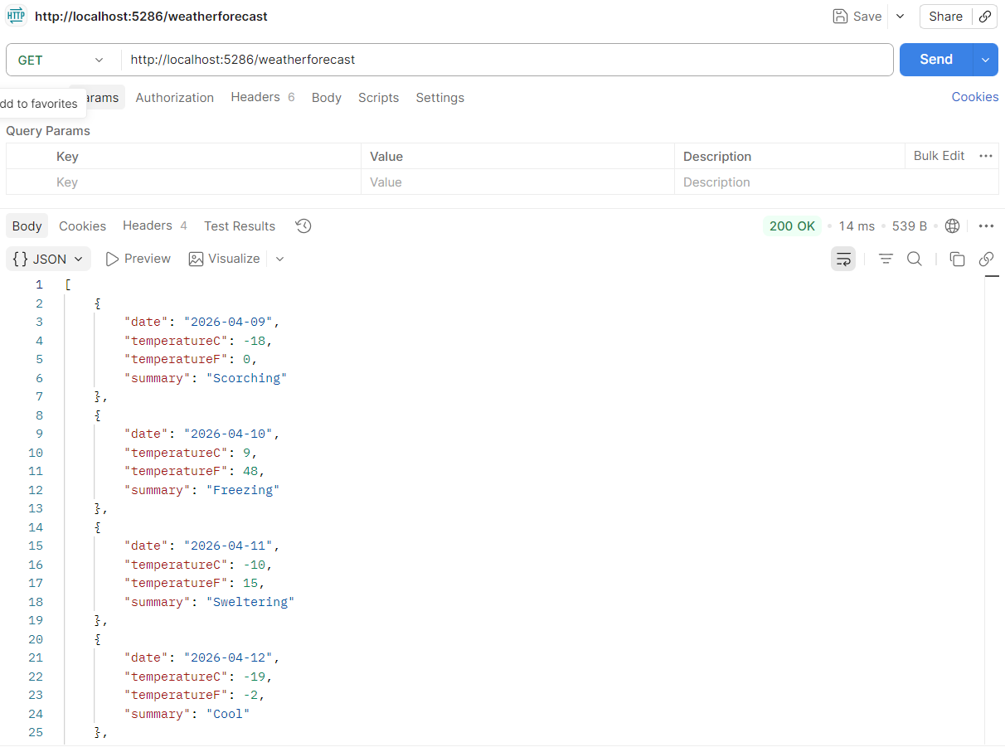

- In the backend, create a directory named Models and inside it, create a file named Employee.cs. Copy the contents of code2-Employee.txt from the repository directory to the Employee.cs in the Models directory.
- In the backend directory, create a directory named Data and in the Data directory create file named: AppDbContext.cs. Copy the content of this file from the code2-backend.txt file from the repository directory.
- Add the following packages using the Terminal:
dotnet add package Microsoft.EntityFrameworkCore -v 9.0.0
dotnet add package Microsoft.EntityFrameworkCore.sqlite -v 9.0.0
dotnet add package Microsoft.EntityFrameworkCore.Tools -v 9.0.0
- Verify the code is still running with the latest updates:
dotnet restore
dotnet run
- Update the local host address and port to match their corresponding values in the image below. This will enable running the app on any interface of the host with these specific port numbers.

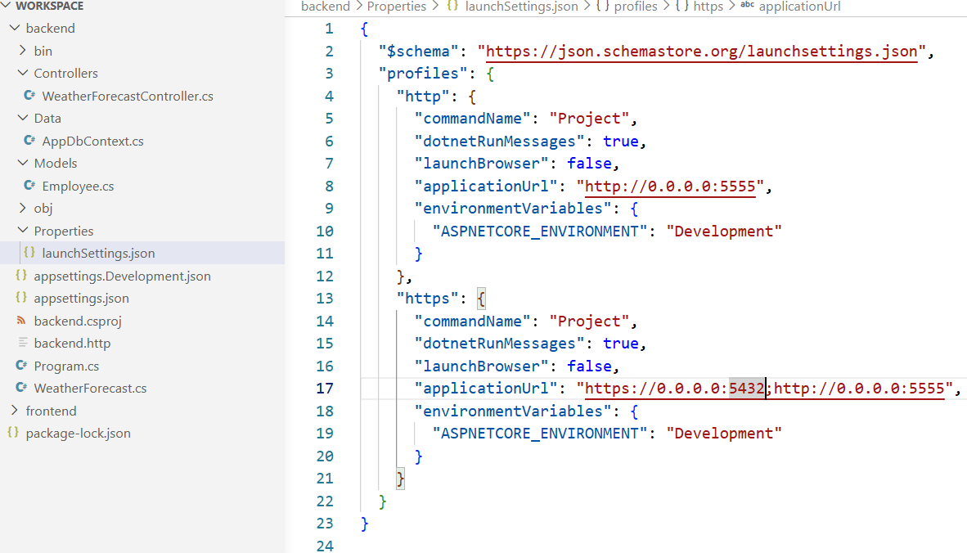
- Rerun the backend. Windows might ask you to allow this operation, accept it and test the app using postman. You can use any of these two links to test it:
http://0.0.0.0:5555/weatherforecast
or
http://localhost:5555/weatherforecast
- From the repository directory, copy the database file company.db and the sqlite.exe engine to the backend directory. This would enable us to run the local sqlite3 database system against the db file.
- Pause on the coding part and try to test the connection to the database. Install the database client from the VS Code extension page. After installing it, you can access it using the barrel icon in the left pane of VS Code.
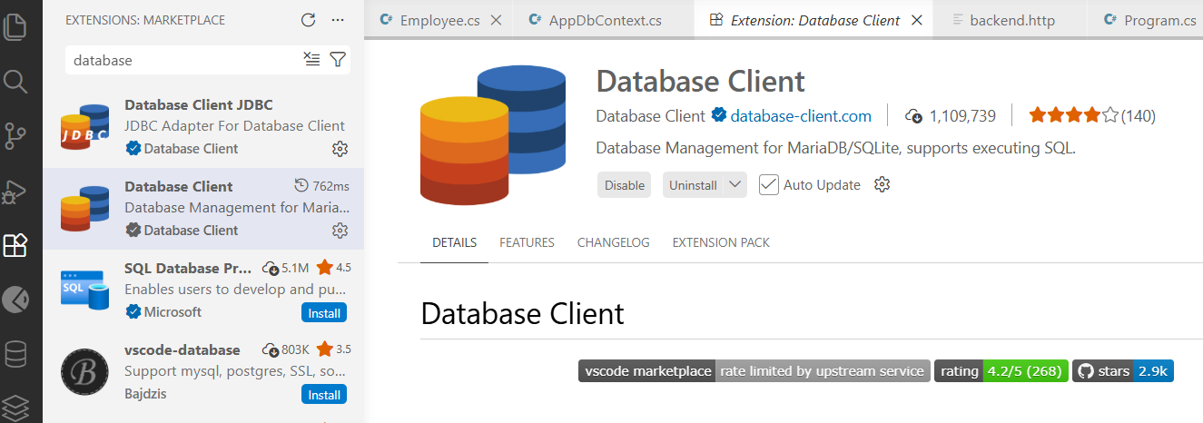

- Test the connection. Provide a connection name, choose SQlite, and browse to the path of the company.db in the backend directory. Save and Connect.
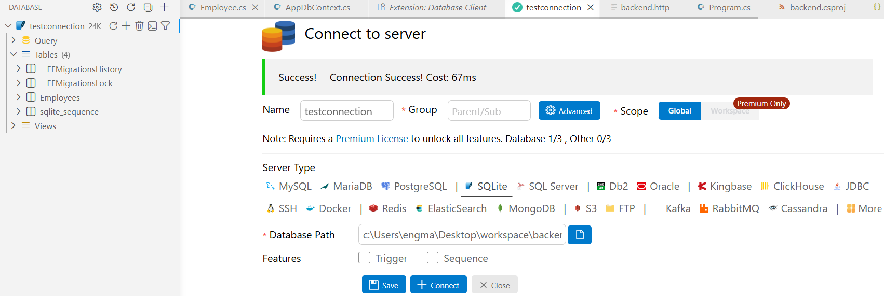
Double click on the Employees table. You will see employee records. We’ll drop the table and all of its data and recreate it in the code. Right click on the table name and drop table Employees;
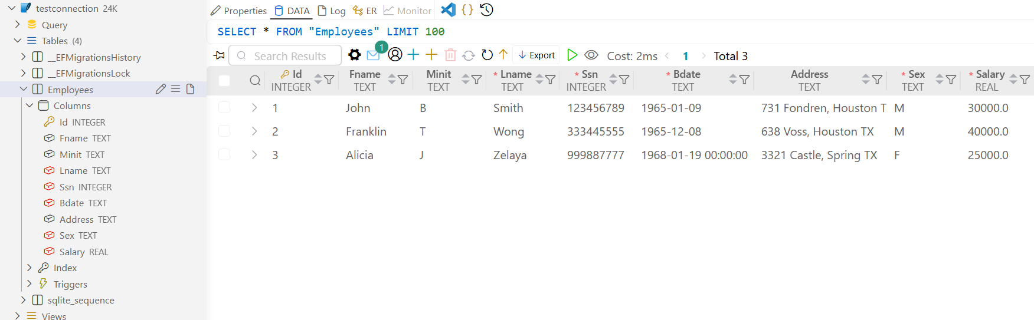
- Navigate to the code, replace the AllowedHosts text with the following text:

"AllowedHosts": "*",
"ConnectionStrings": {
"Default": "Data Source=company.db;"
}
- Navigate to the Program.cs file and Add DBContext to your project. copy this statement in the top: using Microsoft.EntityFrameworkCore; And then this statement right before var app = builder.Build(); statement. See the image below for Program.cs.
builder.Services.AddDbContext<AppDbContext>(
options =>
options.UseSqlite(builder.Configuration.GetConnectionString("Default")
));

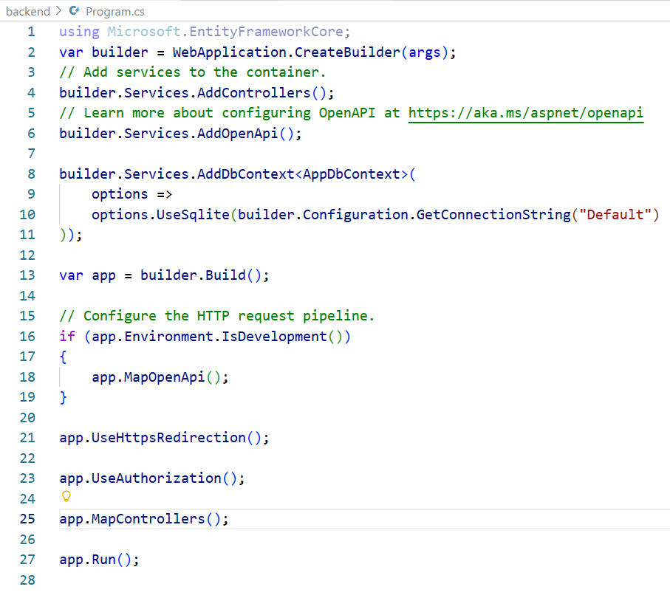

- Install or verify EF in the terminal using the commands:
dotnet ef
dotnet tool install --global dotnet-ef
dotnet ef
- Use the .NET EF ORM modelling to migrate the models to the database using the commands below. Refresh the connection from the database client and you can verify there now exists an Employees table:
dotnet ef migrations add initial
dotnet ef database update
- Create a file named EmployeeController.cs in the Controllers directory.
- Copy the EmployeeController.cs from it corresponding file from the repository: code4-EmployeeController.txt and delete the WeatherForecastController.cs file.
- Insert few Employee records to the Employees table. Copy the sql statement from the sql-statement-Employees.txt to the sql terminal and verify the data in the table.
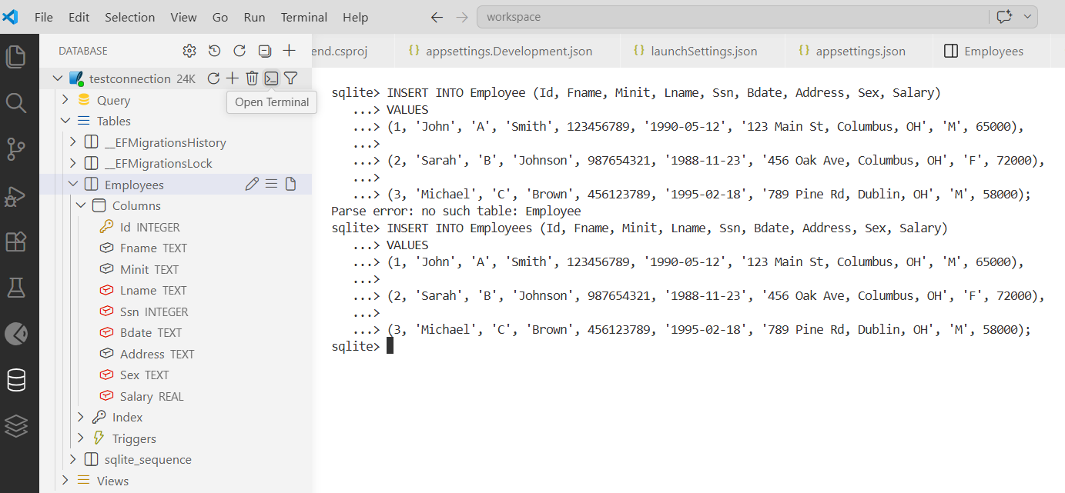
- Try inserting new Employee record using postman. Choose Post from the HTTP verb. Insert the data below in the body. Verify it on the database from the database client extension:
{
"id": 4,
"fname": "Noah",
"minit": "A",
"lname": "Smith",
"ssn": 97654321,
"bdate": "2001-05-12",
"address": "123 Main St, Columbus, OH",
"sex": "M",
"salary": 70000
}
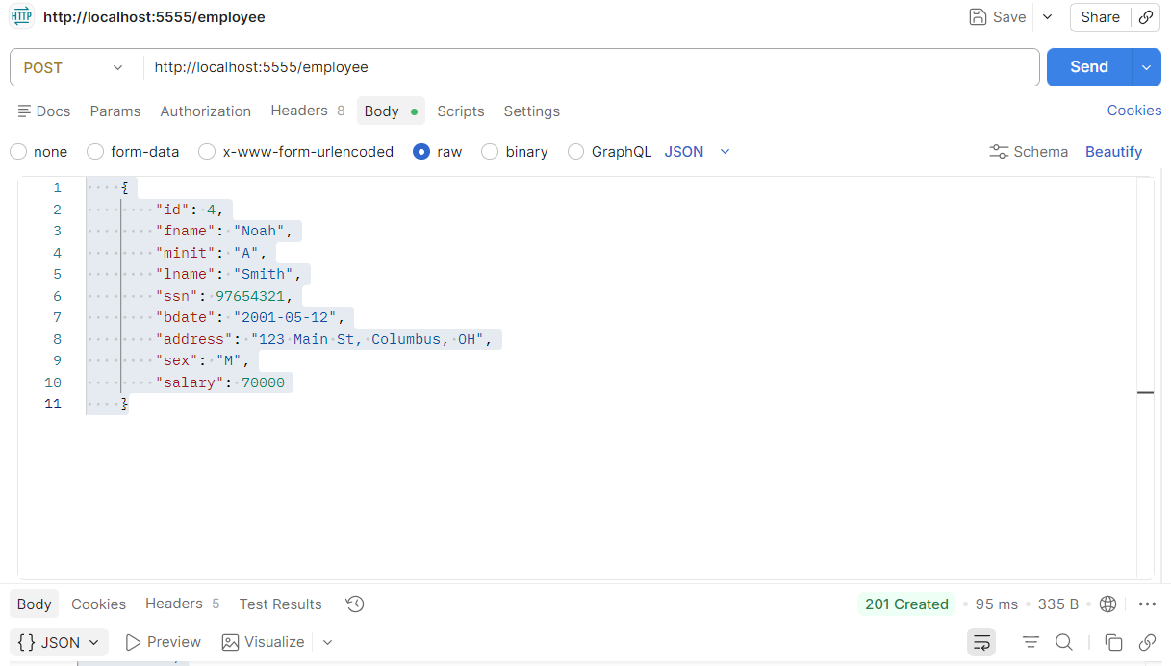

- Try GET verb for record of Employees: http://localhost:5555/employee/1
- Try DELETE verb for one record of Employees.
- Enable CORS between the front end the backend. Copy this code into Program.cs. ensure that you match the frontend URL int the policy.WithOrigns.:
builder.Services.AddCors(options =>
{
options.AddPolicy("AllowFrontend",
policy =>
{
policy.WithOrigins("http://localhost:5173")
.AllowAnyHeader()
.AllowAnyMethod();
});
});

Also Add app.UseCores(“AllowFroned”) as shown below:
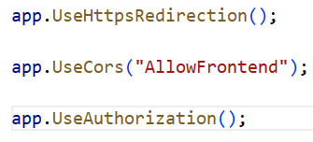

- Now, we want to switch gears back to the frontend so we connect the dots and have everything connected. Stop the program and navigate to the frontend directory:
cd ..
cd frontend
pwd
- Update the contents of the App.tsx from the front end to match code

